**URL** ( Uniform Resource Locator). A URL is nothing more than the address of a given unique resource on the Web. In theory, each valid URL points to a unique resource. Such resources can be an HTML page, a CSS document, an image, etc

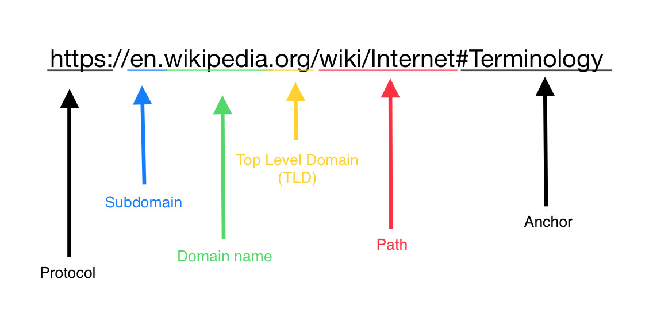Structure of the URL>>>> https://developer.mozilla.org/enUS/docs/Learn/Common_questions/What_is_a_URL